**Day 15 Task: Python Libraries for DevOps**

**Tasks**

1. Create a Dictionary in Python and write it to a json File.
2. Read a json file services.json kept in this folder and print the service names of every cloud service provider.

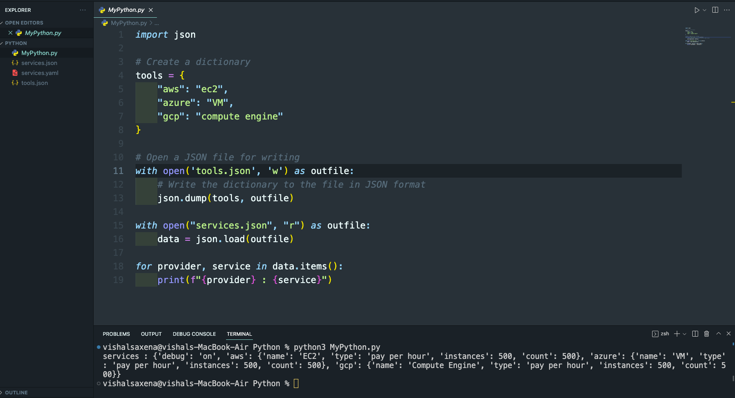

1. Read YAML file using python, file services.yaml and read the contents to convert yaml to json

